Ryan Woodward
100201137

Lab #13: Operating Systems

Note: The exercise / and question numbers below refer to “Laboratory #10: Operating Systems” from the lab book, also available on Blackboard as Lab10.pdf

Type your answers in this file and submit with Blackboard.

Exercise 1 (6 marks)

url: http://faculty.mc3.edu/pvetere/Applets/APPLETS/MEMFITTING/applet_frame.htm

- Start the “Placement of jobs in memory” applet.

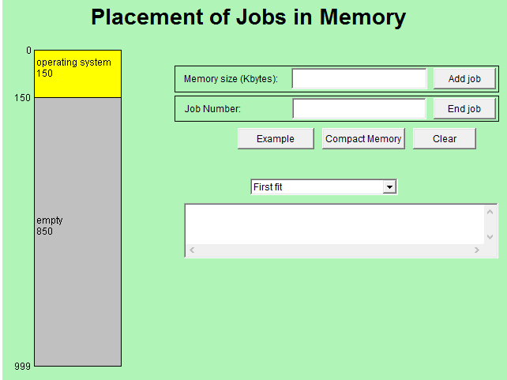

Click on the Example button.

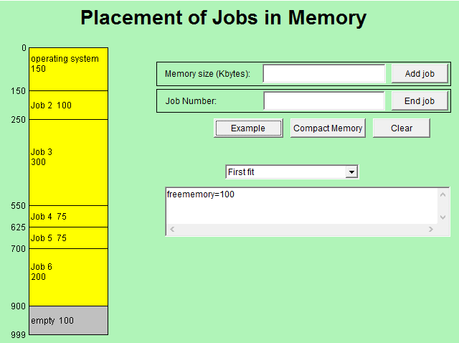

Delete jobs 2 and 5. Use “End job” button

How many holes are there? (holes => empty or free space)
- There are 3 empty holes for free space

What is the total amount of free memory?
- The total amount of free memory is 275 KBytes

What is the largest job that could be entered without compacting the memory?
Memory compaction is a process of relocating information to maximize free space.

- The largest job that can be entered without compacting is 100KBytes.

- Try to add a job that is 125 Kb long.

What happens?
- There is not enough free memory to add this job
Message:
- Could not find a slot

- Compact the memory (click on the Compact button)

How many holes are there? (holes => empty or free space)
- There is only one hole open now

What is the total amount of free memory?
- The total amount of free memory remains the same at 275 KB

What is the largest job?
- The largest job is 300 KB

- Re-start the applet and click on the Example button again.

Options
- You can re-start the applet by closing and reopening your browser.
- Click Clear button

Delete jobs 2 and 5 again.

- Add a job that requires 75 Kb.
Where do you expect it to go?

- 1st available slot ← I expect it to go to the first available slot
- 2nd slot
- 3rd slot
- None of the above

- Redo Step 4. Select the Best fit algorithm from the pull-down menu.
Add a 75 Kb job.

Where will it go and why? Hint: you are using BEST FIT algorithm

- It would go into the 2nd slot since it is the first available slot that maximizes the fit of the job

Take a screenshot.

- Skip (bonus 1 mark)

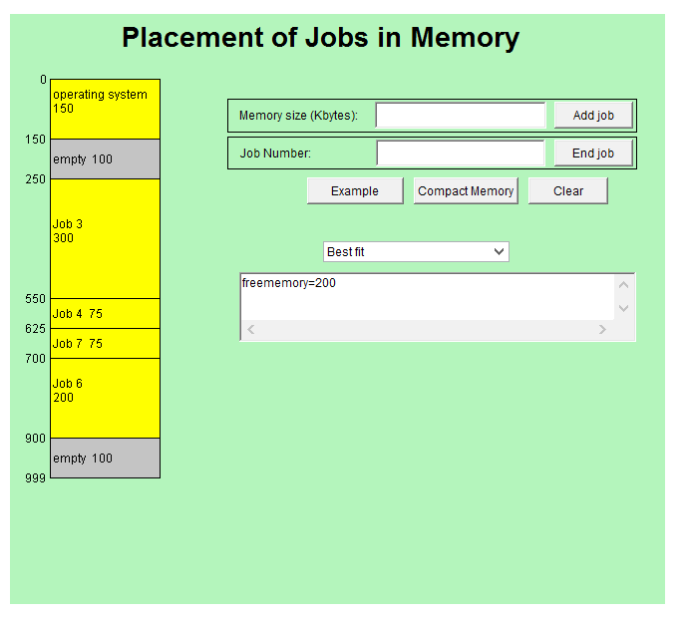

- Since the Compact memory button is there, why doesn’t the operating system always use it when a new job enters? Make a guess as to why frequent compaction is avoided. (bonus, 1 mark)

Ask the instructor SC.

- The amount of jobs that are being performed per second is quite a lot. If frequent compaction were to occur the computer would slow down to a crawl.

Exercise 2 (4 marks)

url: http://faculty.mc3.edu/pvetere/Applets/APPLETS/SCHEDULING/applet_frame.htm

- Start the “Job Scheduling” applet and select Example1 from the drop down list. Four jobs appear in the job list.

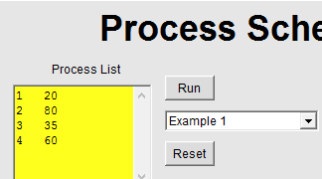

- Run the program using the First-Come, First-Served algorithm.

Time: 195

Average: 112.5

- Select Shortest Job first from the drop-down menu and click on the Run button.
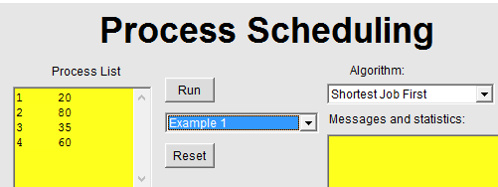

Does this method have the same total time requirement as the First-Come, First-Served algorithm?

- Yes it does as they both took 195 to complete

Average time to completion: 96.25

Is it better than First-Come, First-Served?

    - It is better than first come first served because it estimates which processes take the most time to complete. It can than schedule processes on particular cores to make sure than the cores are running as efficiently as possible.

Take a screenshot.
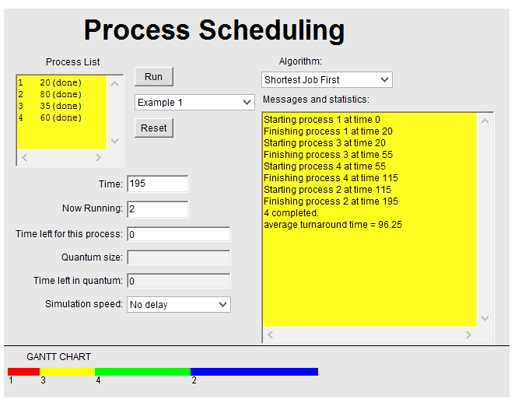
.

- Select Round Robin from the drop-down menu and click on the Run button.

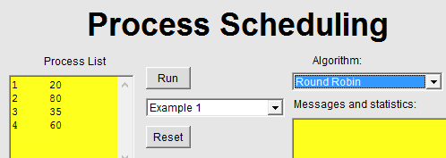

Average time to completion:

- 147.5

How does it compare to the other two methods?

- Slower ← It is slower than the other two methods
- Faster
- Same

Take a screenshot.
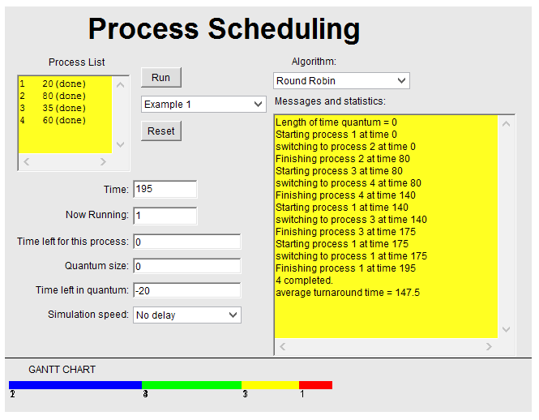

- Looking at the log of activity, what is fundamentally different about Round Robin from the other two job scheduling algorithms? What kind of computing system would likely prefer to use Round Robin?

- What is fundamentally different is that round robin switches processes at time quantum's. Even if a process is not finishes it will suspend it, and switch to another process and begin processing. A computer system that contains a lot of high-time-to-completion processes would benefit from using this method.

(bonus, 1 mark)

